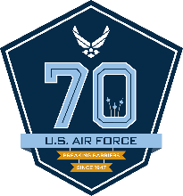****

DEPARTMENT OF THE AIR FORCE

HEADQUARTERS 121ST AIR REFUELING WING (AMC) (ANG)

7370 MINUTEMAN WAY

COLUMBUS, OHIO 43217-1161

Insert Date

MEMORANDUM FOR OFFICE SYMBOL

FROM: OFFICE SYMBOL

SUBJECT: Summary of Memorandum

1. First paragraph here.

2. Second paragraph here. If there is only one paragraph, remove the number “1.”

3. Third paragraph if needed.

JANE I. OKAY, Rank, ANG

Job Title

Attachment:

Name of Attachment

cc:

Name of cc